Revised 3/15/16
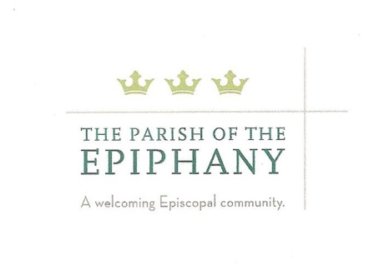
PARISH OF EPIPHANY MISSION AND OUTREACH GRANT REQUEST FORM
This application will be reviewed by members of the M&O Steering team at the next monthly meeting and voted on in that meeting. The grant application will need a majority vote to be approved. We ask that you, the grant writer, or a representative you select, attend the meeting to field any questions that may arise. We will let you know when the next Steering team meeting will be as soon as we receive your application.
GRANT GUIDELINES

Epiphany grants are distributed on an “as needed” basis for emergency or one time needs to organizations:

• with whom we share our deepest, spiritual relationships and to whom our parish devotes numerous volunteer hours each year, organizations that are addressing underlying issues of human rights, supporting diversity, alleviating poverty, hunger, homelessness and offering education and long-term sustainability solutions

Or:

• for need-based scholarships so any parishioner, youth or adult, can participate in a mission trip. For privacy in seeking financial assistance, please speak in confidence directly to Reverend Thomas.
We have a limited amount of funds in our account so only 3-5 grants per year will be dispersed from the Outreach Memorial Fund. Best practice will ensure that a diversity of geographic areas are represented in the missions we support. We will strive to support a balance of established missions where we have had a longstanding relationship as well as new initiatives where there is emerging parishioner support that has potential for growth. Please include a detailed budget of the program/need you are asking Epiphany to support. There is a list of all the grants we have supported since 2011 posted on Epiphany’s Mission and Outreach webpage.
APPLICATION FORM
Date: __________________________________________________________
Organization Name: _______________________________________________
Is this a non-profit with 501c3 status Yes ___________ No _______________
Street address ___________________________________________________
City ____________________ State _______________________ Zip_________
Email ___________________________________________________________
Website _________________________________________________________
Phone: __________________________________________________________
Parish contact(s)/advocate(s): __________________________________________________________________________________________________________________________________________________________________________________________
Briefly describe the program, including goals, objectives and need (including the # of individuals served and what services they will receive, if applicable). Please address how these goals and objectives meet the guidelines listed above: ______________________________________________________________________________________________________________________________________________________________________________________________________________________________________________________________________________________________________________________________________________________________________________________________________________________________________________________________________________________________________________________________________________________________________________
Grant Request Amount:_____________ What % are you asking from Epiphany (vs. from other sources)? ________
Will the funds requested support an ongoing financial need/project or a specific (one-time) need: _______________________________________________________________________________________________________________________________________________________________________________________________________________________________________________________________________________________
We also ask, if the grant is approved, that you commit to reporting back to Epiphany on how the grant was used, either in a summary report that will be shared with our community via the 3 Crowns and other media, or by presenting to our parish at a special educational evening, during one of our mini-series or in adult ed.
Please email this form to Susan Haskell, grants chair, @ susanhaskell33@gmail.com or leave it in the Outreach mailbox in Epiphany’s office.

